
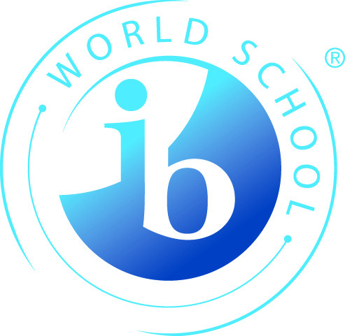

WINSTON CHURCHILL HIGH SCHOOL
1605 – 15th Avenue North
LETHBRIDGE AB T1H 1W4

Telephone: (403) 328-4723 FAX: (403) 329-4572
E-mail: morgan.day@lethsd.ab.ca Web Page: www.wchs.lethsd.ab.ca

Application to the Churchill Pre-IB program for students entering Grade 10

Section A - Personal Information:

Surname:_____________________ First Name:___________________ Middle Name:______________

Telephone No._________________ E-mail Address:________________________________________

Mailing Address:____________________________________________ City:________________________

Postal Code:_____________ Date of birth:_____ _____ _____ Advisor: ___________________
D M Y

Parent/Guardian Name(s):________________________________________________________________

Section B or C - Previous School: (Complete section B or C, not both)

B – Churchill Students  I am completing my Grade 9 year at:  (check one below)  Winston Churchill High School | C – Other Schools  I am completing my Grade 9 year at:  School Name:____________________________________  School Address:__________________________________  School Phone Number: ____________________________  School email: ____________________________________

Section D - Academic Performance: (Indicate Grade 9 report card marks to date)

Subject | Current | Teacher’s Name
Language Arts
Social Studies
Math
Science
French or Spanish
(if applicable)

(A photocopy of your most recent report card may be attached to this application form as an alternative to completing the above table.)

Please complete the reverse
Section E - IB Application Details:
Note: We strongly recommend that students enrol as full IB students in the Churchill Pre-IB program. It is always possible to switch to a partial program later.

Please indicate if you are seeking:
Full (Diploma) status: __________
or Partial (Certificate) status: __________
Indicate each of the Churchill Pre-IB courses you would like to take. Full Diploma students must complete courses in all six subject groups. In groups 2 and 6 you must indicate one preference from within the list provided:
______ Group 1: English - register in English 10i.
Group 2: Second Language Select one of the following:
______ Spanish (can be a beginner) - register in Spanish 10.
______ French B (requires previous French studies) - register in French 10i

______ Group 3: Global Politics - register in Social 10i.
______ Group 4: Biology - register in Science 10i.
______ Group 5: Math - register in Math 10i and Math 20i.
Group 6: Elective Select one of the four choices:
Most of these electives happen in grade 11 but you need to take the grade 10 pre-requisite.
______ Art IB - register in Art 10.
______ Drama IB - register in Drama 10.
______ Music IB – must have some previous music background.
______ Chemistry IB - register in Science 10i.

Note: Even though you choose a group 6 subject now, it is sometimes possible to change your selection in your Grade 11 year. For example, if you take Art or Drama 10, then decide that you would prefer Chemistry IB, you may switch to Chemistry as long as you have successfully completed Science 10i and Math 10i.

All group 6 electives require teacher permission for acceptance into the course. In the case of Art, Drama and Chemistry, Grade 10 prerequisites must be completed.
Music IB students do not have to be in the band or choir, however some music background is necessary. Students taking private lessons with an instrument or in voice will likely qualify. Also, students who have participated in middle school band or choir will be eligible.

If you have any questions about the collection, use or disclosure of this information, please contact:
Morgan Day, Vice Principal, IB Coordinator
WINSTON CHURCHILL HIGH SCHOOL
1605 – 15th Avenue North
LETHBRIDGE AB T1H 1W4
Telephone: (403) 328-4723 or E-mail: morgan.day@lethsd.ab.ca

